|  |
| --- |
| Installation Guide  SecretManager v0.8-x |

|  |  |
| --- | --- |
| Abstract : | This guide details how an IT administrator shall install the tool « **SecretManager** ». |

|  |  |  |
| --- | --- | --- |
| REVISION HISTORY | | |
| Version | Date | Description of Change |
| 1.0-0 | 17/12/2013 | Creation of document |
| 1.1-0 | 19/03/2014 | Updated document |
| 1.2-0 | 22/05/2014 | Reviewed and minor notes added |

|  |  |  |
| --- | --- | --- |
| REFERENCES | | |
| Index | Title | Reference |
|  |  |  |
|  |  |  |

Summary

1. FOREWORD 4

2. Caution 4

3. PREREQUISITES 5

3.1. Minimum Apache installation 5

3.2. minimum PHP installation 5

3.3. phpMyAdmin Installation 5

4. Packaging de l’outil 5

5. STEPS TO INSTALL 6

5.1. Step 1 6

5.2. Step 2 6

5.3. Step 3 6

5.4. Step 4 6

6. RESOURCES ADJUSTMENT 10

6.1. File detail « Constants.inc.php » 11

7. First Connection TO « SecretManager » 11

8. ERRORS « SecretManager » CONNECTION 13

8.1. Error connecting to database 13

9. « SecretServer » installation 14

9.1. « SecretServer » setting 14

9.2. Start « SecretServer » 14

9.2.1. Test start « SecretServer » 14

# FOREWORD

The tool "**SecretManager**" is written in PHP 5 and relies on default MySQL database application.

This document does not describe how to install the software infrastructure such as:

* Apache 2.4.9 ;
* PHP 5.5.11 ;
* MySQL 5.6.16 ;
* SSL 1.0.1g.

To do so, please refer to the installation guide of these specific softwares.

# Caution

You use this tool at your own risk.

Although this version is a "beta", you can start using this product in production.

If you use " **SecretManager** " without the " **SecretServer** ", then the file "Config_Hash.inc.php" must be protected so that only the "root" user and the owner of the application " **SecretManager** " can access it. The owner of the application " **SecretManager** " is the user running the Apache instance that runs the application itself " **SecretManager**."

# PREREQUISITES

As seen above, the tool " **SecretManager** " is written in "PHP 5" application. " **SecretManager** " forcing the dialogue "HTTPS", therefore, you must install "OpenSSL" and use an appropriate certificate in accordance with your Company constraint. During the development and testing, we used the pre-packaged solution « XAMPP for Mac OSX 1.8.3-4 ».

## Minimum Apache installation

The version of Apache that was used during development was version:

Apache/2.4.9 (Unix) PHP/5.5.11 OpenSSL/1.0.1g

## Minimum PHP installation

PHP version that was used during development was version "5.4.16".

PHP must be compiled with the following modules (at minimum) :

|  |  |
| --- | --- |
| Module | Version / Extension |
| Hash | sha1 |
| Mcrypt | 2.5.8 with rijndael-256 |
| PDO | mysqlnd 5.0.11-dev – 20120503 |
| OpenSSL | 1.0.1g -- 7 Apr 2014 |
| Session |  |

## phpMyAdmin Installation

« phpMyAdmin » version that was used during development was "4.1.12" version.

# Tool Packaging

The tool " **SecretManager** " is provided as an archive.

To distinguish an archive another, the version number is represented by the three last digits in the archive name ("SecretManager-vN.N-N.zip" where N.N-N is the version number).

Thus, this archive is called:

SecretManager-v0.8-5.zip

You can also find archives named "Upd-SecretManager-vN.N-N.zip." This archive type is used to make an update with respect to a previously installed version.

**Important**: an archive update does not reset the database and does not overwrite customization files either (Libraries / CONFIG_ * php.). However, if a previous version was not installed, " **SecretManager** " will not work.

# INSTALLation steps

## Step 1

You must copy the installation or update zip file in the "DocumentRoot" defined in the "httpd.conf" of your Apache server.

For an update, please refer to the "IMPORTANT_README" file embedded in the zip file.

## Step 2

You need to unpack the archive that has been copied (see 5.1). Unpacking is dependent on the operating system of your server. The deliverable being a "zip" file, please use the appropriate tool.

## Step 3

Once unpacked, the archive, must produce the following directories and subdirectories:

|  |  |  |
| --- | --- | --- |
| Directory | Subdirectory | |
| SecretManager |  |  |
|  | Backup |  |
|  | boostrap |  |
|  | Documentations |  |
|  | Installation |  |
|  | Libraries |  |
|  |  | Labels |
|  |  | Radius |
|  |  |  |
|  | Pictures |  |
|  | Temp |  |

## Step 4

Connect to the "phpMyAdmin" tool as "root" in "MySQL" database.

On the home page "phpMyAdmin", skip the interface language to "English" and change the theme to "pmahomme."

You should get the screen below:

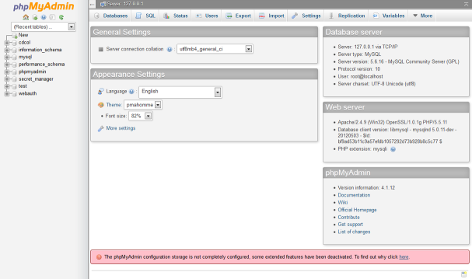

In this interface, use the "Import" tab. After clicking on this tab, you will get the screen below:

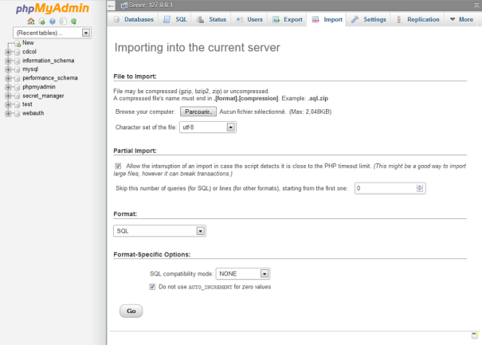

It is important to keep the "Character set of the file" to "utf-8".

Then, click on the "Browse ..." button. This action brings up a window in which you must specify the SQL files to run.

SQL files are in the "Installation" directory of your " **SecretManager** ".

These files are:

|  |  |
| --- | --- |
| Name | Designation |
| Secret_Manager-0.sql | This SQL file creates the "Secret_Manager" database, and all its tables.  **Warning**: This script deletes the database if it already existed. You will lose all previous data. |
| Secret_Manager-1.sql | This SQL file creates the user database « iica_user ». This user is one that allows "**SecretManager**" to access the "secret_manager" database. It is the user’s database. |
| Secret_Manager-2.sql | **Warning**: you must first select the database "Secret_Manager" before running this script.  This SQL file inserts the data, such as data reference tables. It also creates the "root" user application. This user is the default « **SecretManager**» Administrator. |

# Configuration

Although normally you do not have to change the layout resource " **SecretManager** ", it is however possible. To do this, you must edit the file "Constants.inc.php" which is located in the root directory of "**SecretManager**". As its name suggests, this file defines all the constants used by the application.

**Important**: remember that if you move a resource, you must make sure that the user running the Apache server dedicated to " **SecretManager** " is allowed to read and write in these resources.

The administrator installing " **SecretManager** " must be attentive to the resource: "SERVER". This resource allows to rewrite the URL to each internal call to " **SecretManager** ". It must point to either an "IP address" or a "DNS entry." In both cases, this means the server hosting the " **SecretManager** " and " **SecretServer**", as both components must be located on the same server.

For example, suppose your " **SecretManager** " is the designated server IP address "10.192.120.1".

In the « Constants.inc.php » file, you should have the following line:

define( 'SERVER', '10.192.120.1' );

In your "httpd-vhosts.conf" file, you should have the following block:

<VirtualHost 10.192.120.1:443>

ServerName secretmanager.localhost

ServerAlias SecretManager

DocumentRoot "/Applications/XAMPP/xamppfiles/htdocs/SecretManager"

SSLEngine on

SSLCertificateFile "/Applications/XAMPP/xamppfiles/etc/ssl.crt/server.crt"

SSLCertificateKeyFile "/Applications/XAMPP/xamppfiles/etc/ssl/server.key"

ServerAdmin admin@orasys.fr

<Directory /Applications/XAMPP/xamppfiles/htdocs/SecretManager>

DirectoryIndex index.php

AllowOverride All

Order allow,deny

Allow from all

</Directory>

CustomLog logs/ssl_request_log "%t %h %{SSL_PROTOCOL}x %{SSL_CIPHER}x \"%r\" %b"

</VirtualHost>

These sample files are located in the "Installation" directory. It is your responsibility to configure and install them in the appropriate directory.

## File detail « Constants.inc.php »

This file stores all constants necessary for the proper functioning of the " **SecretManager**." These constants are used to locate internal " **SecretManager** " resources. You will find below a description of each of these constants:

| Constant | Description |
| --- | --- |
| SERVER | This constant locates the server. An IP address or DNS entry can be used to locate this server. It may be necessary to ensure consistency between the value of this constant and your VHOST define. |
| APPLICATION_PATH | This constant locates the installation directory on your « **SecretManager**». |
| URL_BASE | This constant is used to locate components « **SecretManager**» for their calls. |
| URL_PICTURES | This constant is used to locate the images that will be displayed in the « **SecretManager**» screens |
| URL_LIBRARIES | This constant is used to locate « **SecretManager**» "style sheets" and "Javascripts". |
| DIR_SESSION | This constant is used to locate files "session" users. |
| DIR_LIBRARIES | This constant is used to locate « **SecretManager**» objects. |
| DIR_LABELS | This constant is used to locate the « **SecretManager**» labels. |
| DIR_RADIUS | This constant is used to locate the RADIUS environment. |
| DIR_PICTURES | This constant is not yet used. |
| DIR_BACKUP | This constant is used to locate the « **SecretManager**» "backup" file. |
| FLAG_ERROR | This constant is used to signal an error. |
| FLAG_SUCCESS | This constant is used to signal a success. |
| IICA_DB_CONFIG | This constant locates the access configuration file to the database. |
| IICA_LIBRARIES | This constant is used to locate « IICA » objects. |
| IICA_PICTURES | This constant is used to locate « IICA » pictures. |
| IICA_LABELS | This constant is used to locate « IICA » labels. |
| MAIL_BODY | This constant locates the "template" file to create the "body" email alerts. |

# First Connection TO « SecretManager »

Start with a local connection to your server. To do this, use your browser and type the address of the server where you installed « **SecretManager**»:

https://10.192.120.1/

You should get the screen below:

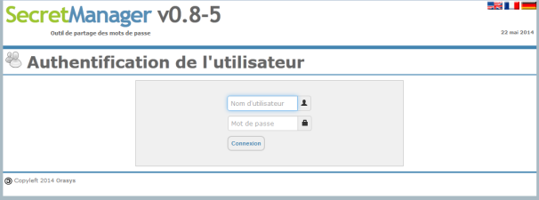

As the tool has been installed, the default user is "root" and the default password is "Welcome !" (space is important between "e" and "!").

**Warning**: we recommend that you change this password before taking the « **SecretManager**» tool to a Production environment, see use a "super-admin" different account.

You should arrive on the screen below:

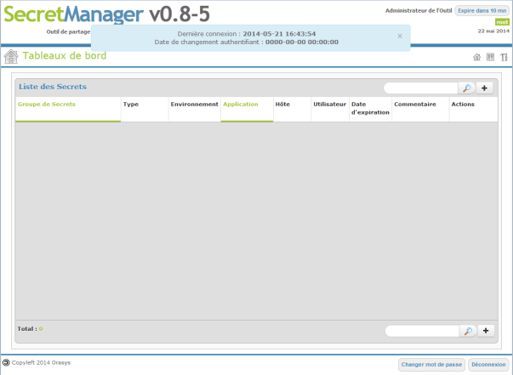

If this is the case, your installation is complete and you can start using the "Administration Guide".

# ERRORS « SecretManager » CONNECTION

There may be many errors, but here are some investigation tips:

## Error connecting to database

Environment variables managing the access to the database are defubed in the "Config_Access_DB.inc.php" file in the "Libraries" sub-directory of the "SecretManager" root directory installation.

The credentials for user "iica_user" should be the one defined in the database.

Constant "IICA_DB_CONFIG" defined in your "Constants.inc.php" should then redirect to this file.

# « SecretServer » installation

The « **SecretServer**» is located in the same directory as the « **SecretManager**». The difference is that « **SecretServer**» is not a Web application. Instead, the « **SecretServer**» runs as a background task on your system.

**Important**: The user who runs the « **SecretServer**» must be the same user running the Apache server dedicated to « **SecretManager**». Attention should be given to sharing directory "DIR_SESSION" and "DIR_LIBRARIES" for granting access to this user (see chapter **6.1**). Indeed, the « **SecretServer**» accesses sessions of different users who come to him to ensure the rights of these users.

## « SecretServer » setting

By default, at startup « **SecretServer**» uses the configuration file below:

Libraries/Config_SM-secrets-server.inc.php

This file is used to define 3 importants parameters:

1. IP address (knowing that for the moment, only the localhost works) ;
2. Listening port (by default, $IP_Port = 10000) ;
3. The name of the file that will stored the “ Mother key “ (by default, $SecretFile = 'Libraries/secret.dat'). Mother key is the key used to encrypt secrets in the database.

Normally, only the IP port number should be changed.

## Start « SecretServer »

To start the « **SecretServer**», use the following commands:

$ cd ${SECRET_MANAGER}

$ php SM-secrets-server.php

${SECRET_MANAGER} corresponds to the « **SecretManager** » installation directory.

While you are in test mode, please use the "DEBUG" mode to run your « **SecretServer** ».

To do so, run the following commands:

$ cd ${SECRET_MANAGER}

$ php SM-secrets-server.php **-d**

For more information on the available options, run the following command:

$ php ${SECRET_MANAGER}/SM-secrets-server.php **-h**

To encapsulate these commands, it is recommended to run them with the same account of the server hosting the « **SecretServer** » and running Apache.

**Important**: The "SM-secrets-server.php" calls files based on the current path. Therefore, it is mandatory to navigate to the SECRET_MANAGER installation directory before running « **SecretServer** ».

### Test start « SecretServer »

It is possible to start the « **SecretServer** » in the background using the "SUDO" command, as shown below:

$ sudo –b php ${SECRET_MANAGER}/SM-secrets-server.php